**Predict Heart Failure Using IBM Auto Ai Service**

Krishna Priya G – Assistant Professor – Department of Computer Science and Engineering, Jansons Institute of Technology, Coimbatore, Tamilnadu, India.

krishna.kcse@gmail.com

**Category: IBM Cloud Application**

**Skills Required:**  
IBM Nodered,IBM Watson Studio,IBM Machine Learning

**Project Description:**

Cardiovascular diseases (CVDs) are the number 1 cause of death globally, taking an estimated 17.9 million lives each year, which accounts for 31% of all deaths worldwide.

Heart failure is a common event caused by CVDs and this dataset contains 9 features that can be used to predict mortality by heart failure.

In this project, you need to build a model using Auto AI and build a web application where we can get the prediction of heart failure.

**Services Used:**

1. IBM Watson Studio
2. IBM Watson Machine Learning
3. Node-RED
4. IBM Cloud Object Storage

**Architecture:**

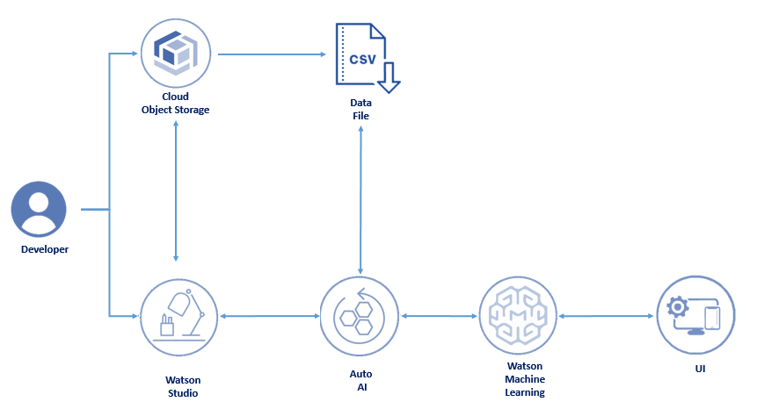

**1.1 Process Flow :**

The overall process flow is depicted in the following figure Fig 1.1.

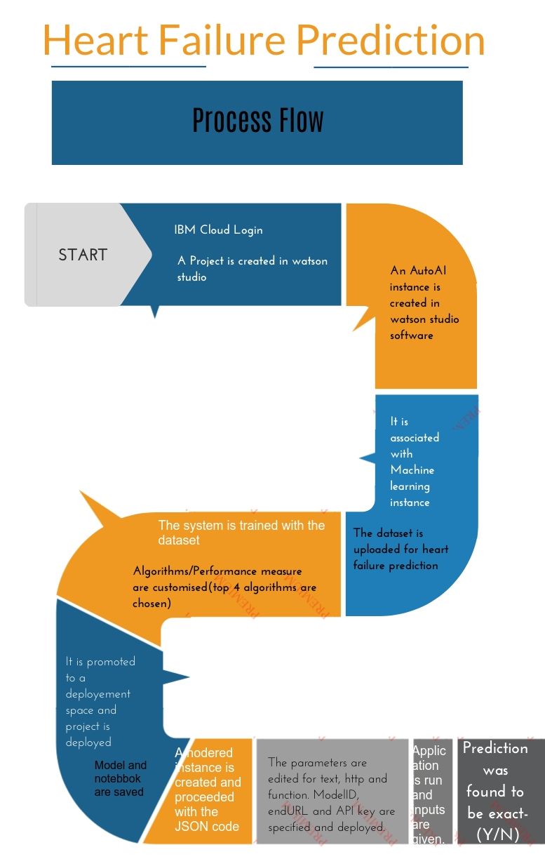

**Fig 1.1 Prediction of Heart Failure using Watson Studio, AutoAI and NodeRED**

**2. Procedure :**

**2.1 Create AutoAI Experiment :**

 Create a project in **watson studio**

 Create a autoAI experiment in the **Asset** page in software option

 It is associated with the **machine learning instance**

**2.2 Dataset :**

 The dataset is downloaded from github which has 9 columns with 10801 rows. Link : <https://github.com/IBM/predictive-model-on-watson-ml/blob/master/data/patientdataV6.csv>

**2.3. Training the model :**

 AutoAI analyses the dataset and cassifies it as **Y/N** based on the inputs.

 It automatically trains and produces an output as **Binary Classification problem**.

 The performance measure best chosen by autoAI system is **accuracy**.

 The settings are customized for runing top 4 algorithms and it is executed.

**2.4. Experiment Results :**

 The experiment summary is depicted in Fig 2.4.1 where it shows 4 different algorithms performance.

 It can be visualised that **16 pipelines** are created (4 for each algorithm)

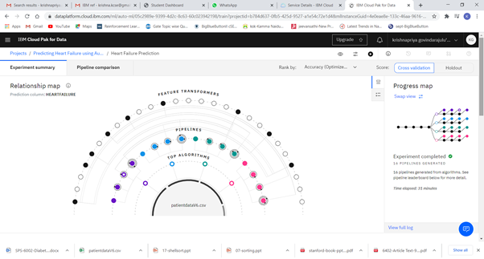

**Fig 2.4.1 Experiment Summary - Relationship Map**

 The infographics is also represented in the pipeline format in Fig 2.4.2.

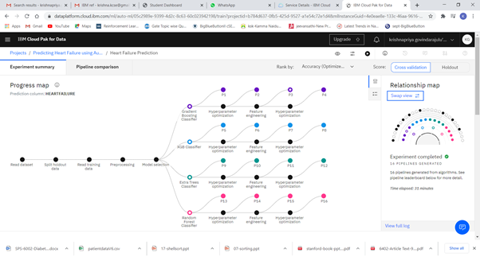

**Fig 2.4.2 Experiment Summary - Pipeline Comparison**

 Once the pipeline  completed, the ranked pipelines is viewed in a leaderboard and various results like **precision-recall curve, confusion matrix** are visualised.

 The pipeline leaderboard has a comparison of all **16 pipelines** specifying the parameters algorithm,accuracy, average prediction,F1,Log loss, Precision, Recall, ROC/AUC which shall be referred in Fig 2.4.3

 The best **accuracy value 0.874** was found in **Gradient Boosting algorithm**.

 A deployement space is created and the model is deployed by associating with the machine learning instance.

* It is tested with test data and verified for results.

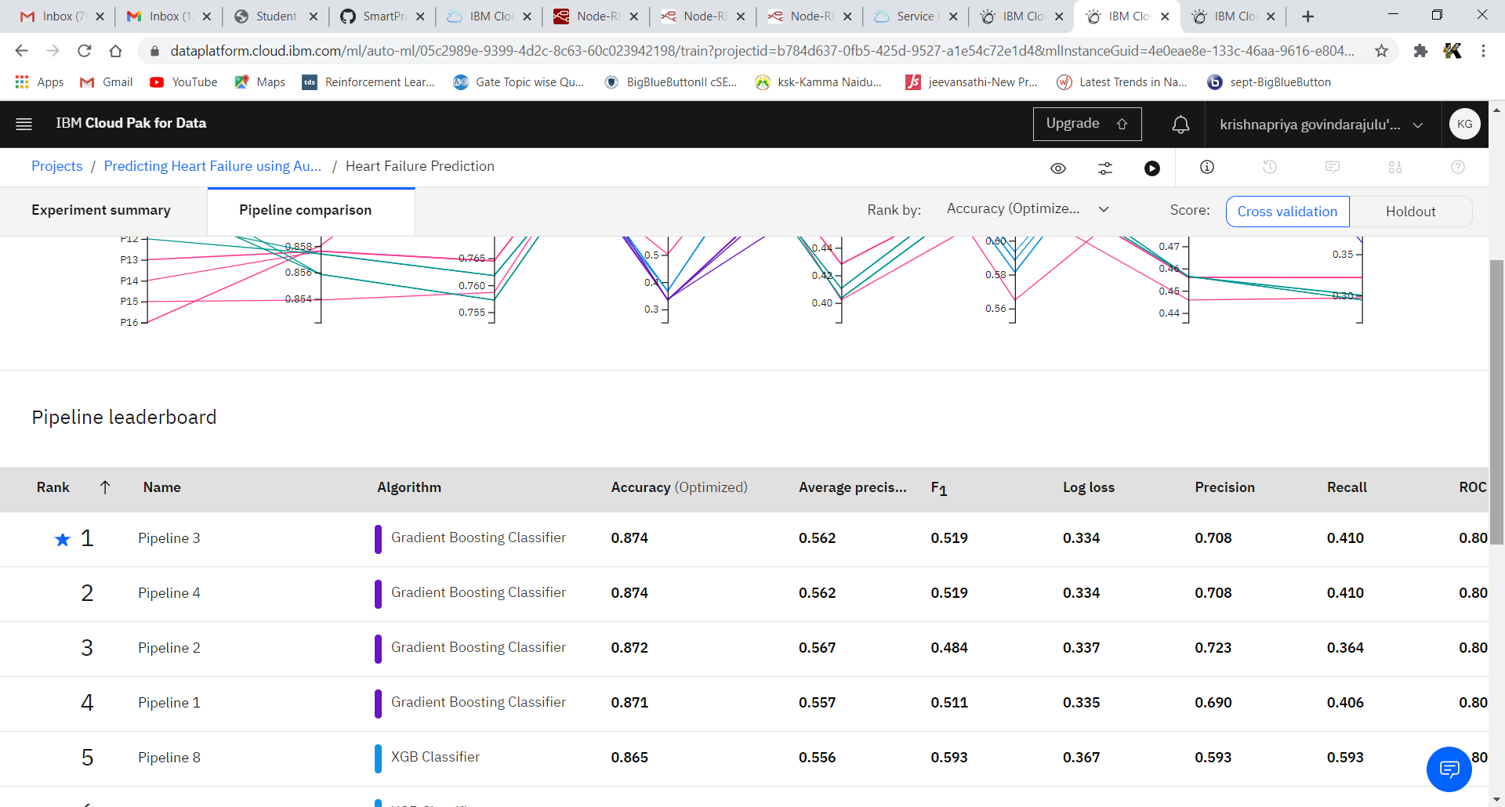

**Fig 2.4.3 Pipeline leaderboard (Chart and Tabulation View)**

**2.5. UI Design :**

 Inorder to create an interface and to test the values, IBM cloud is accessed and **NodeRED Application** is created with an instance.

 The project is built and deployed here.

 In NodeRED flow editor the flow diagram is constructed as depicted in Fig 2.5.1.

 The **JSON code** is imported and the parameters for form, functions and HTTP are edited according to the dataset.

 The following parameters are accessed from the AutoAI project and linked here**.**

* + **Model id**
  + **URL**
  + **API key**

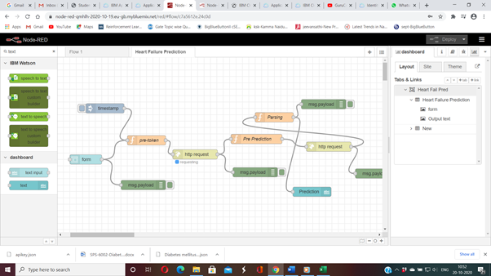

**Fig 2.5.1 Nodered Flow Diagram**

**2.6 Output : Prediction -  Y (Heart Failure):**

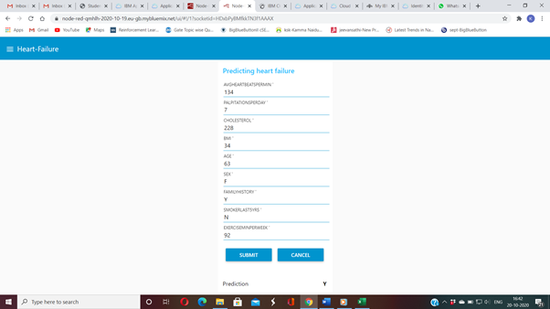

**Prediction - N (No Heart Failure):**

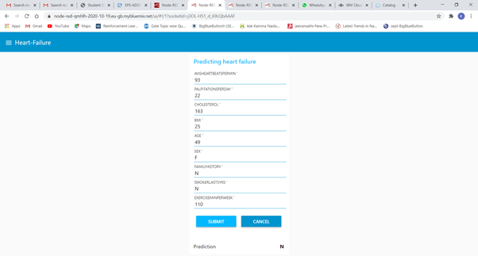

**3. Conclusion :**

      The prediction of heart failure is one of the mostly needed requirement in the medical field. Here without any coding the automatically built IBM services are utilised and a Binary classification AutoAI model is executed successfully. 4 algorithms were chosen and so 16 pipelines are executed. The performance measure which the model resulted is accuracy with the Gradient Boosting Algorithm with a best result of 0.874.  The build time 00:00:33, which is saved as model and deployed. The model is further tested and integrated with Node Red service for interfacing and creating a web service. It is seen that the model exactly predicted the class Y/N representing the possibility of Heart Failure/No Heart Failure. Thus, the IBM Watson studio, AutoAI, NodeRED and Cloud services are utilised and a model is automatically deployed successfully without any implementation of coding.